**Exp 8 Computation of LEAD and TRAIL**

**Name: -** Sai Mohit Ambekar

**Reg No: -** RA1911031010137

**Class: -** CSE-IT (L2 Section)

**AIM:**

A program to implement computation of leading and trailing.

**ALGORITHM:**

1. For Leading, check for the first non-terminal.

2. If found, print it.

3. Look for next production for the same non-terminal.

4. If not found, recursively call the procedure for the single non-terminal present before the comma or End Of Production String.

5. Include it's results in the result of this non-terminal.

6. For trailing, we compute same as leading but we start from the end of the production to the beginning.

7. Stop

**CODE:**

#include<iostream>

#include<conio.h>

#include<stdio.h>

#include<string.h>

#include<stdlib.h>

using namespace std;

int vars,terms,i,j,k,m,rep,count,temp=-1;

char var[10],term[10],lead[10][10],trail[10][10];

struct grammar

{

int prodno;

char lhs,rhs[20][20];

}gram[50];

void get()

{

cout<<"\nEnter the no. of variables: ";

cin>>vars;

cout<<"\nEnter the variables: \n";

for(i=0;i<vars;i++)

{

cin>>gram[i].lhs;

var[i]=gram[i].lhs;

}

cout<<"\nEnter the no. of terminals: ";

cin>>terms;

cout<<"\nEnter the terminals: ";

for(j=0;j<terms;j++)

cin>>term[j];

cout<<"\nPRODUCTION DETAILS\n";

for(i=0;i<vars;i++)

{

cout<<"\nEnter the no. of production of "<<gram[i].lhs<<":";

cin>>gram[i].prodno;

for(j=0;j<gram[i].prodno;j++)

{

cout<<gram[i].lhs<<"->";

cin>>gram[i].rhs[j];

}

}

}

void leading()

{

for(i=0;i<vars;i++)

{

for(j=0;j<gram[i].prodno;j++)

{

for(k=0;k<terms;k++)

{

if(gram[i].rhs[j][0]==term[k])

lead[i][k]=1;

else

{

if(gram[i].rhs[j][1]==term[k])

lead[i][k]=1;

}

}

}

}

for(rep=0;rep<vars;rep++)

{

for(i=0;i<vars;i++)

{

for(j=0;j<gram[i].prodno;j++)

{

for(m=1;m<vars;m++)

{

if(gram[i].rhs[j][0]==var[m])

{

temp=m;

goto out;

}

}

out:

for(k=0;k<terms;k++)

{

if(lead[temp][k]==1)

lead[i][k]=1;

}

}

}

}

}

void trailing()

{

for(i=0;i<vars;i++)

{

for(j=0;j<gram[i].prodno;j++)

{

count=0;

while(gram[i].rhs[j][count]!='\x0')

count++;

for(k=0;k<terms;k++)

{

if(gram[i].rhs[j][count-1]==term[k])

trail[i][k]=1;

else

{

if(gram[i].rhs[j][count-2]==term[k])

trail[i][k]=1;

}

}

}

}

for(rep=0;rep<vars;rep++)

{

for(i=0;i<vars;i++)

{

for(j=0;j<gram[i].prodno;j++)

{

count=0;

while(gram[i].rhs[j][count]!='\x0')

count++;

for(m=1;m<vars;m++)

{

if(gram[i].rhs[j][count-1]==var[m])

temp=m;

}

for(k=0;k<terms;k++)

{

if(trail[temp][k]==1)

trail[i][k]=1;

}

}

}

}

}

void display()

{

for(i=0;i<vars;i++)

{

cout<<"\nLEADING("<<gram[i].lhs<<") = ";

for(j=0;j<terms;j++)

{

if(lead[i][j]==1)

cout<<term[j]<<",";

}

}

cout<<endl;

for(i=0;i<vars;i++)

{

cout<<"\nTRAILING("<<gram[i].lhs<<") = ";

for(j=0;j<terms;j++)

{

if(trail[i][j]==1)

cout<<term[j]<<",";

}

}

}

int main() {

get();

leading();

trailing();

display();

}

**OUTPUT:**

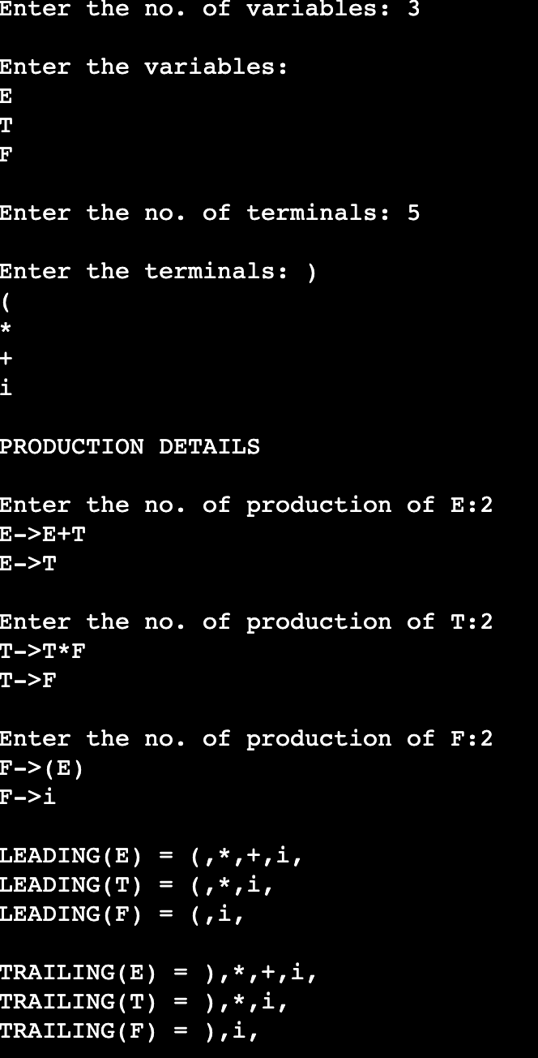

**RESULT:**

The program for leading and trailing was successfully compiled and run.